Q6. Electricity Bill Calculation – Java Program Design a Java program to calculate the electricity bill for a customer based on the number of units consumed. Implement a class named ElectricityBill with the following specifications: Class: ElectricityBill Instance Variables ● customerName (String): Name of the customer ● unitsConsumed (double): Number of electricity units consumed ● billAmount (double): The calculated bill amount Constructor ● A parameterized constructor to initialize the customerName and unitsConsumed fields. Method ● void calculateBillAmount(): This method calculates the electricity bill amount based on the following tariff rules: ○ First 100 units: Rs. 5 per unit ○ Next 200 units (i.e., 101 to 300): Rs. 7 per unit ○ Remaining units (above 300): Rs. 10 per unit Main Program In the main() method: 1. Create an object of the ElectricityBill class. 2. Set the customerName and unitsConsumed values (can be taken from user input or hardcoded). 3. Call the calculateBillAmount() method to compute the bill. 4. Display the customer's name, units consumed, and final bill amount. use solution class

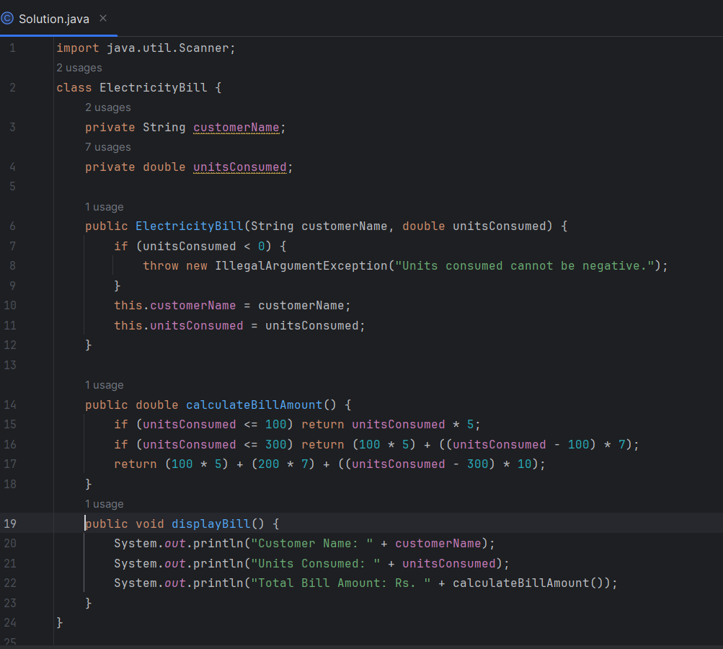

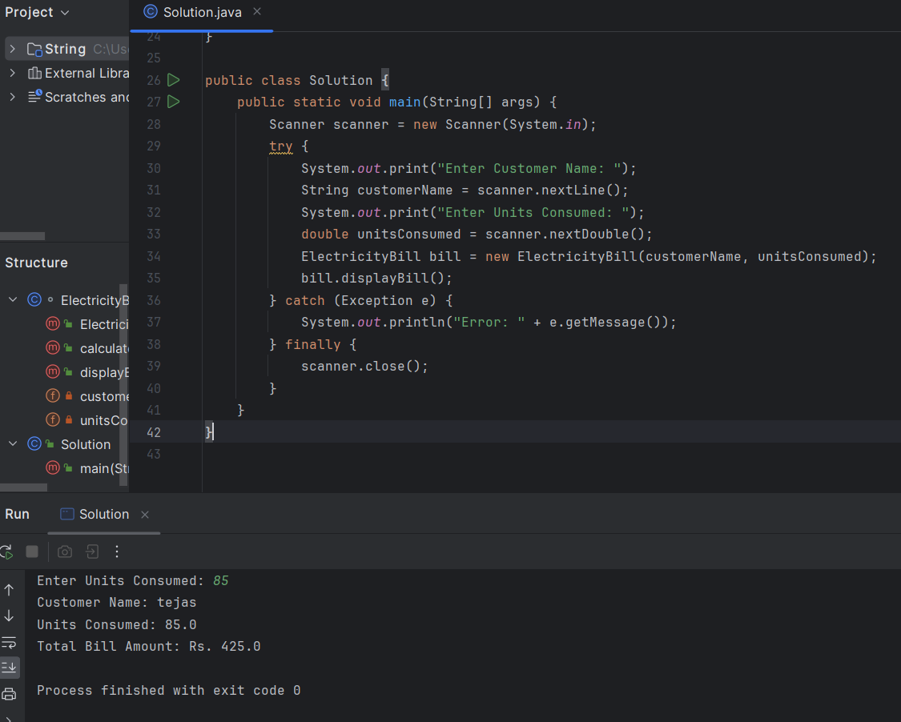

Q2. Student Marks and Grade Calculation with Exception Handling Design a Java program to calculate the total marks, average, and grade of a student, with proper exception handling for invalid inputs. Implement a class named Student with the following specifications: Class: Student Instance Variables ● name (String): Name of the student ● rollNo (int): Roll number of the student ● marks (double array of size 5): Marks obtained in 5 subjects ● average (double): Average marks ● grade (char): Grade based on average Constructor ● A parameterized constructor to initialize the name, rollNo, and marks. ● Throw an IllegalArgumentException if any mark is negative or greater than 100. Methods ● void calculateAverage(): Computes the average of marks. ● void calculateGrade(): Assigns grade based on the average as per the following criteria: ○ A: average ≥ 90 ○ B: 80 ≤ average < 90 ○ C: 70 ≤ average < 80 ○ D: 60 ≤ average < 70 ○ F: average < 60 ● void displayStudentInfo(): Displays the student’s name, roll number, marks, average, and grade. Main Program In the main() method: 1. Prompt the user to input student details and marks for 5 subjects. 2. Use a try-catch block to handle the following: ○ InputMismatchException for non-numeric input ○ IllegalArgumentException for invalid mark entries (e.g., < 0 or > 100) 3. Create a Student object, calculate average and grade, and display the full information.

